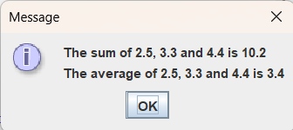
package as1;

import javax.swing.JOptionPane;

public class Average {

public static void main(String[] args) {
double n1;
double n2;
double n3;
double sum, avg;
String in, out;
in = JOptionPane.showInputDialog ("Enter the first number");
//convert the String into a double.
n1 = Double.parseDouble (in);

in = JOptionPane.showInputDialog("Enter the second number");
n2 = Double.parseDouble (in);

in = JOptionPane.showInputDialog("Enter the third number");
n3 = Double.parseDouble (in);

sum = n1 + n2 + n3;
avg = sum / 3;

//Build the out String

out = "";
out = out + "The sum of " + n1 + ", " + n2 + " and " + n3 + " is " + sum + "\n";
out = out + "The average of " + n1 + ", " + n2 + " and " + n3 + " is " + avg;

JOptionPane.showMessageDialog(null, out);
System.exit (0);

}

}

